[YourProject] Design Document

November 11, 2019

Use this Requirements Specification template to document the requirements for your product or service, including priority and approval (Must do).
This document will also serve as a System Design Document (How to) and will include sections detailing system flow, algorithms, staffing plan, software/hardware, and Test Plan
This document contains instructions and examples which are for the benefit of the person writing the document and should be removed before the document is finalized.
To regenerate the TOC, select all (CTL-A) and press F9.
Table of Contents
1. Executive Summary 3
1.1 Project Overview 3
1.2 Purpose and Scope of this Specification 3
2. Product/Service Description 3
2.1 Product Context 3
2.2 User Characteristics 3
2.3 Assumptions 3
2.4 Constraints 3
2.5 Dependencies 4
3. Requirements 4
3.1 Functional Requirements 5
3.2 Security 5
3.2.1 Protection 5
3.2.2 Authorization and Authentication 6
3.3 Portability 6
4. Requirements Confirmation/Stakeholder sign-off 6
5. System Design 6
5.1 Algorithm 6
5.2 System Flow 6
5.3 Software 6
5.4 Hardware 6
5.5 Test Plan 7
5.6 Task List/Gantt Chart 7
5.7 Staffing Plan 7

Executive Summary

Project Overview
Our robot must be able to perform three different tasks. These tasks include moving around the room in a rectangle, move in a figure 8 five times and stop and the same spot and finally go through an obstacle course.

Purpose and Scope of this Specification
The purpose of this is to show problem solving skills and the intended audience is our Professor, Gil Eckert.

Product/Service Description
In order for the product to work you will want to have an open space with a flat floor for optimal performance.

Product Context
This product is used with application on IOS and Windows Devices. You can use a Computer or even you smart phone to connect to the product.

=============User Characteristics
This product would be very useful to children trying to get into computers at a young age, or even older students who are just trying to gain some knowledge about software engineering

Assumptions
- Need a Sphero device
- No knowledge needed, could be very experienced

Constraints
Some constraints could be battery life. If the robot is low on battery it will not receive your code as well. The rubber protection could also be a problem because each one is different.

Dependencies
The device will need the code to operate, you should also charge before use because it will result in the robot failing to receive code if it is running low on battery.

Requirements
- Describe all system requirements in enough detail for designers to design a system satisfying the requirements and testers to verify that the system satisfies requirements.
- Organize these requirements in a way that works best for your project. See Error: Reference source not foundError: Reference source not found, Error: Reference source not found for different ways to organize these requirements.
- Describe every input into the system, every output from the system, and every function performed by the system in response to an input or in support of an output. (Specify what functions are to be performed on what data to produce what results at what location for whom.)
- Each requirement should be numbered (or uniquely identifiable) and prioritized.
See the sample requirements in Functional Requirements, and Error: Reference source not found, as well as these example priority definitions:
Priority Definitions
The following definitions are intended as a guideline to prioritize requirements.
- Priority 1 – The requirement is a “must have” as outlined by policy/law
- Priority 2 – The requirement is needed for improved processing, and the fulfillment of the requirement will create immediate benefits
- Priority 3 – The requirement is a “nice to have” which may include new functionality
It may be helpful to phrase the requirement in terms of its priority, e.g., "The value of the employee status sent to DIS must be either A or I" or "It would be nice if the application warned the user that the expiration date was 3 business days away". Another approach would be to group requirements by priority category.
- A good requirement is:
- Correct
- Unambiguous (all statements have exactly one interpretation)
- Complete (where TBDs are absolutely necessary, document why the information is unknown, who is responsible for resolution, and the deadline)
- Consistent
- Ranked for importance and/or stability
- Verifiable (avoid soft descriptions like “works well”, “is user friendly”; use concrete terms and specify measurable quantities)
- Modifiable (evolve the Requirements Specification only via a formal change process, preserving a complete audit trail of changes)
- Does not specify any particular design
- Traceable (cross-reference with source documents and spawned documents).

Functional Requirements
In the example below, the requirement numbering has a scheme - BR_LR_0## (BR for Business Requirement, LR for Labor Relations). For small projects simply BR-## would suffice. Keep in mind that if no prefix is used, the traceability matrix may be difficult to create (e.g., no differentiation between '02' as a business requirement vs. a test case)
The following table is an example format for requirements. Choose whatever format works best for your project.
For Example:
Req# | Requirement | Comments | Priority | Date Rvwd | SME Reviewed / Approved
BR_LR_05 | The system should associate a supervisor indicator with each job class. | Business Process = “Maintenance | 3 | 7/13/04 | Bob Dylan, Mick Jagger
BR_LR_08 | The system should handle any number of fees (existing and new) associated with unions. | Business Process = “Changing Dues in the System”  An example of a new fee is an initiation fee. | 2 | 7/13/04 | Bob Dylan, Mick Jagger
BR_LR_10 | The system should capture and maintain job class status (i.e., active or inactive) | Business Process = “Maintenance”  Some job classes are old and are no longer used. However, they still need to be maintained for legal, contract and historical purposes. | 2 | 7/13/04 | Bob Dylan, Mick Jagger
BR_LR_16 | The system should assign the Supervisor Code based on the value in the Job Class table and additional criteria as specified by the clients. | April 2005 – New requirement. It is one of three new requirements from BR_LR_03. | 2
BR_LR_18 | The system should provide the Labor Relations office with the ability to override the system-derived Bargaining Unit code and the Union Code for to-be-determined employee types, including hourly appointments. | April 2005 – New requirement. It is one of three new requirements from BR_LR_04.  5/11/2005 – Priority changed from 2 to 3. | 2  3

Security

Protection
The Sphero application will protect your code from other people if you want to keep it private under you account.

Authorization and Authentication
In order to gain access to private code, you need to have the right username and password to access the account if the code is private.

Portability
The system is able to be transported to different devices, even if they run on different operating systems. It will be able to be transported from and IOS device to a windows device with ease.
Meeting Date | Attendees (name and role) | Comments
10/25/19 | Joe Von Dollen – Group Member  Ryan Trent – Group Member  Emilia B – Group Member | Tested our code
 | Bob Dylan, Labor Relations SME  Mick Jagger, Labor Relations SME  Ringo Starr, Technical Project Manager | Deferred / Deleted: BR_LR_01 - BR_LR_04, BR_LR_07, BR_LR_12, BR_LR_14, BR_LR_15, BR_LR_06, BR_LR_17

System Design
This section will provide all details concerning the technical design, staffing, coding, and testing the system

Algorithm

- Steps
- Position robot so that the blue light is facing you
- Press start
- Robot moves forward at a speed of 255 for 4.33 seconds
- Stop
- Rotate 90 degrees
- Move forward at a speed of 150 for 4 seconds
- Stop
- Rotate 180 degrees
- Move forward at a speed of 255 for 4.33 seconds
- Stop
- Rotate 270 degrees
- Move forward at a speed of 150 for 4 seconds
- Stop
- Flash red
- Say “I’m done and I need water”

stem Flow

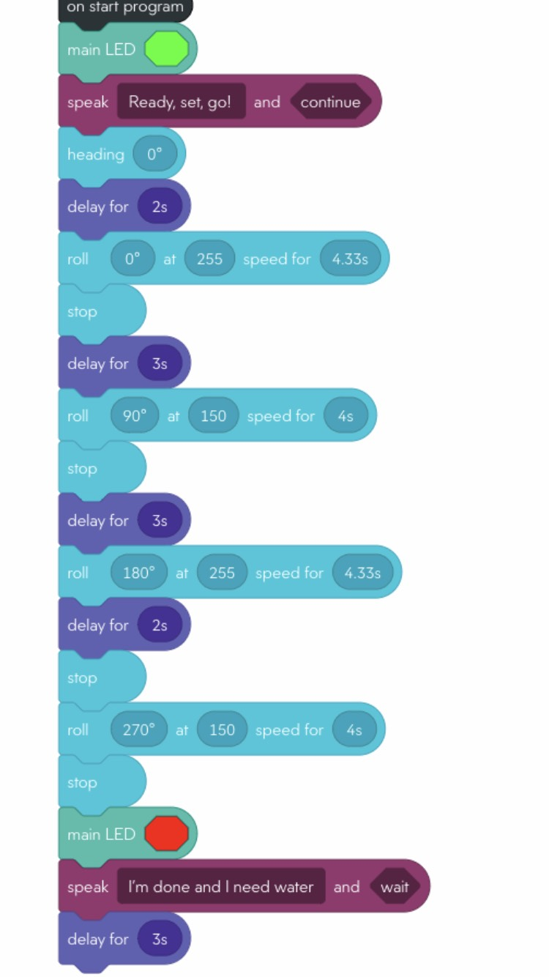

Software
The software language that is used is already given in the app, just input the speed and degrees of turning.

Hardware
What we used for our project was our iPhone and computers.

Test Plan

Reason for Test Case | Test Date | Expected Output | Observed Output | Staff Name | Pass/Fail
Tried to see if we could get the robot to stop on the yellow block by eyeballing the distance | 10/20 | The robot will stop on the block | The robot stopped too short | Joe, Ryan, Emilia | Fail
We increased the amount of travel time for the robot | 10/20 | The robot will stop on the block | The robot hit the wall | Joe, Ryan, Emilia | Fail
Shortened the time for the robot to travel | 10/20 | The robot stopped at the block | The robot stopped at the block | Joe, Ryan, Emilia | Pass
We eyeballed the degrees the robot will have to turn | 10/20 | The robot will turn and facing the other block | The robot turned and started facing the right direction | Joe, Ryan, Emilia | Pass
We shortened the distance for the robot to travel since the blocks are closer | 10/22 | The robot will make it to the second block | The robot did not make it far enough | Joe, Emilia | Fail
We made the distance longer for the robot to travel | 10/22 | The robot will make it to the second block | The robot made it to the second block | Ryan, Emilia | Pass
We copied the distances for the rest of the sprint and put it all together | 10/23 | The robot will make it around the entire classroom | The robot made it around the entire classroom, but was not completely straight | Joe, Ryan, Emilia | Fail
We took the rubber part off the robot and tried again | 10/23 | The robot will make it around the entire classroom | The robot made it around the entire classroom | Joe, Ryan, Emilia | Pass

Task List/Gantt Chart

Staffing Plan
Insert a chart/table that depicts the roles and responsibilities of each team member that worked on this project

Name | Role | Responsibility | Reports To
Joe | Group Member | Gant chart
Ryan | Group Member | Task list
Emilia | Group Member | Code

